Devika.B
roll no.22

DATE : 10 - FEB - 2025

ASSIGNMENT – 1

Even-Odd Classification

AIM :
Write a Java program to check whether an input number is even or odd.

Program :

import java.util.Scanner;
public class EvenOdd{
public static void main(String arg[]){
Scanner s=new Scanner(System.in);
System.out.print("enter the num:");
int num=s.nextInt();
if(num%2==0){
System.out.println("Even");

}
else{
System.out.println("Odd");
}
}
}

OUTPUT

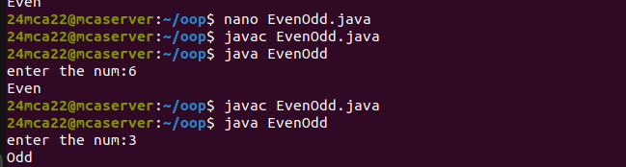

ASSIGNMENT – 2

Sum of First n Natural Numbers

AIM :
Write a Java program to compute the sum of the first n natural numbers.

Program :

import java.util.Scanner;
public class Sum{
public static void main(String arg[]){
System.out.print("Enter the n:");
Scanner s=new Scanner(System.in);
int n=s.nextInt();
int r=0;
for(int i=0;i<=n;i++){
r=r+i;
}
System.out.println("sum="+ r);
}
}

OUTPUT

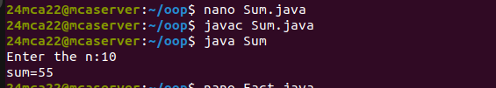

ASSIGNMENT – 3

Factorial of a Number

AIM :
Write a Java program to check whether an input number is even or odd.

Program :
import java.util.Scanner;
public class Fact{
public static void main(String arg[]){
System.out.println("enter the num:");
Scanner s=new Scanner(System.in);
int n=s.nextInt();
int r=1;
for(int i=1;i<=n;i++){
r=r*i;
}
System.out.println("fact:"+ r);
}
}

OUTPUT

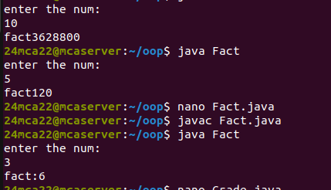

ASSIGNMENT – 4

Assigning Grades Based on Numeric Score

AIM :
Write a Java program to check whether an input number is even or odd.

Program :

import java.util.Scanner;
public class Grade{
public static void main(String arg[]){
System.out.print("enter the mark:");

Scanner s=new Scanner(System.in);
int mark=s.nextInt();
if(mark>=90)
System.out.println("grade A");
else if(mark>=80)
System.out.println("grade B");
else if (mark>=70)
System.out.println("grade C");
else if(mark>=60)
System.out.println("grade D");
else
System.out.println("fail");
}
}

OUTPUT
